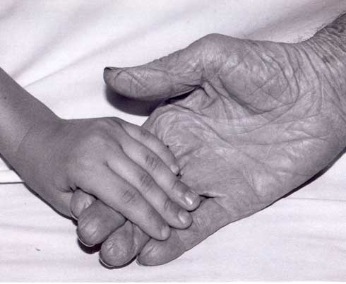
Harvey and Ethel Daeumer Foundation
2175 Point Blvd. #150
Elgin, IL 60123
hedfnd@gmail.com
www.daeumer.org

Mission Statement:
To support local charitable causes for children’s education, health, development and welfare; and improvements and comfort for the sick, aged, or disabled.

Charitable Fund Request Form
Please be sure to review: 1) the grant request requirements and 2) the post-grant requirements as listed on the www.daeumer.org website.

Organization Name:

Contact Person:

Full Address:

Telephone Number:

E-Mail Address:

If you are not available, who do we contact?

Is your organization Non-Profit or Tax Exempt? Include copy of 501©(3) Tax ID Letter – (NOT the sales tax exemption letter). If you do not have a 501(c)(3) Letter, you are not eligible to apply for a grant.

To help clarify our areas of focus:

Do you serve people from Elgin, South Elgin or Dundee, or their neighboring towns? _____
(We are a local Foundation, and this describes our service area. If the answer is “no”, this will likely affect your eligibility)
Does your cause include music, choir, or the arts? _____ (If the answer is “yes”, the Foundation by-laws specifically disqualifies these from consideration.)
________________________________________________________________________________

Project Name:

Amount of funding requested: $__________

How many lives will this directly effect? ______ (a number only, please)

Description/Purpose of Project:

Do you have a time requirement or completion date for allocation of funding?

Proposed Budget for the project: (Include total expected itemized income and itemized expenses. If more space is needed, please attach a separate page.)

Are any funds used for administrative overhead? If yes, what percentage.

Is your project a one-time or ongoing project?

Briefly describe how this project will be of benefit to the Community:

Any other information you would like us to know:

IMPORTANT: Please attest that you have read and agree to the following:
If you are awarded a grant:
- You are responsible for providing a donation receipt within 15 days of receiving your check.
- You are responsible and required to provide a detailed summary upon completion of the project which will include applicable copies of paid receipts, a post program budget, and a signed transmittal attesting to the use of the funds for what they were intended.
- This information is detailed under the Post Grant Requirements link on the www.Daeumer.org Website.

By signing below, I attest that I have read and agree to the above grant requirements.

______________________________ ____________________________________
Print Name/Title Sign and Date

This is form is to facilitate a request. Additional information may be required. Rev 07/14/2022

